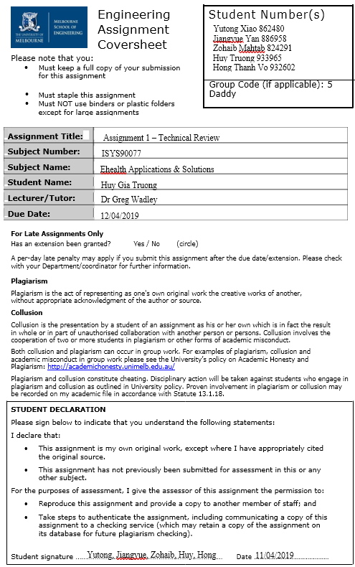

Table of Contents

1. Introduction 1

2. Literature Review 1

2.1. Research Question & Search Strategy 1

2.2. Identified Health Condition 1

2.3. Design Opportunity & Personas 2

2.3.1 Personas 2

2.4. Evaluation of Existing Technological Intervention 4

2.4.1 Motivation 4

2.4.2 Evaluation 4

3. Discussion 6

3.1 Opportunities 6

3.2 Vision 7

3.3 Conceptual Design 7

4. Conclusion 8

5. References 9

# 1. Introduction

Expecting a baby can be an exciting yet challenging experience for both fathers and mothers-to-be. Without adequate preparation and support for this big change, future parents will likely to encounter distress and apprehension, which can lead to prolonged mental health problems. In this report, we aim to explore the most common mental health problem over the course of pregnancy together with its root causes. Popular technological intervention designated for this mental health problem will then be evaluated for their efficacy. These insights, including strengths and weaknesses of each intervention, will serve as the building block of conceptual-design of a future technological intervention, envisioning to help future parents to be better mentally prepared for their upcoming baby.

# 2. Literature Review

## 2.1. Research Question & Search Strategy

To gain insight into antenatal mental health problems and the available intervention, the following research question was constructed:

“What are the root causes and available technological intervention for mental health problems during pregnancy ?”

Based on this research question, literature published from 2015 and later were gathered and analyzed from multiple sources, including IEEE, Google Scholars, Scopus and Pubmed, using the following keywords combination:

|  |  |  |  |  |
| --- | --- | --- | --- | --- |
| “pregnan*” | AND | “mental health*”  OR  “mental issue*”  OR  “mental problem*” | AND | “intervent*”  OR  “mobile app*”  OR  “mhealth” |

**Table 1:** Lookup Keywords.

## 2.2. Identified Health Condition

Antenatal depression is one of the most common mental health issues of pregnant women around the world. In fact, up to 17% of pregnant women in Australia has experienced this health condition, which is directly linked to adverse pregnancy outcomes such as stillbirths and neonatal deaths (Ogbo et al., 2018). There are several risk factors that can lead to antenatal depression, with lacking social support has been proved to be a major factor in several studies (Adewuya et al., 2007; Bayrampour et al., 2015). According to Biaggi et al., (2016), social support has three main components, which are discussed below to explain how they all can lead to antenatal depression.

* **Informational support:** Because the consultation time with healthcare providers are often not enough, pregnant women are becoming less dependent on doctors or midwife for pregnancy advice and instead, turn to health web sites and mobile applications (Guerra-Reyes, Christie, Prabhakar, Harris, & Siek, 2016). However, medical information is notoriously difficult and vast for an untrained person to comprehend, not to mention a large effort to extract and filter for reliable health information sources. This further adds mental pressure and confusion to those who wish to obtain the information, leading to pregnant women and their family members feel overwhelmed by the amount of information across different pregnancy stages.
* **Instrumental & Emotional support:** The physical transformation of women body during pregnancy increase difficulty for them in doing everyday activities. This also led to unstable psychological states such as mood swing and stress, result from hormone changes (Atkinson & Teychenne, 2019). In addition, because high perceived support and marital satisfaction are the key factors to prevent antenatal depression (Biaggi et al., 2016), pregnant women will need a considerable amount of support, both physically and emotionally, from their partner and family relatives. However, lifestyle factors such as unbalanced work-life, small family size and social stigma (E.g. judgments for single-mother and tensions in in-law relationship) make it harder for pregnant women to communicate their needs and timely receive supports from their loved ones, hence further increase the risk for depression (Biaggi et al., 2016).

## 2.3. Design Opportunity & Personas

From the above analysis, we argue that informational support for future parents can be improved by providing them with convenient access to credible and easy-to-understand pregnancy health information. In addition, establishing and bonding a positive relationship with partner and family relatives is pivotal to satisfy both physical & emotional support needs in pregnant women.

### 2.3.1 Personas

To develop a technological solution that delivers the above objectives, the following section describes the characteristics and needs of different stakeholders in the new solution. **Figure 1, 2 and 3** illustrate persona of pregnant women, partner/family relatives and obstetrician respectively.

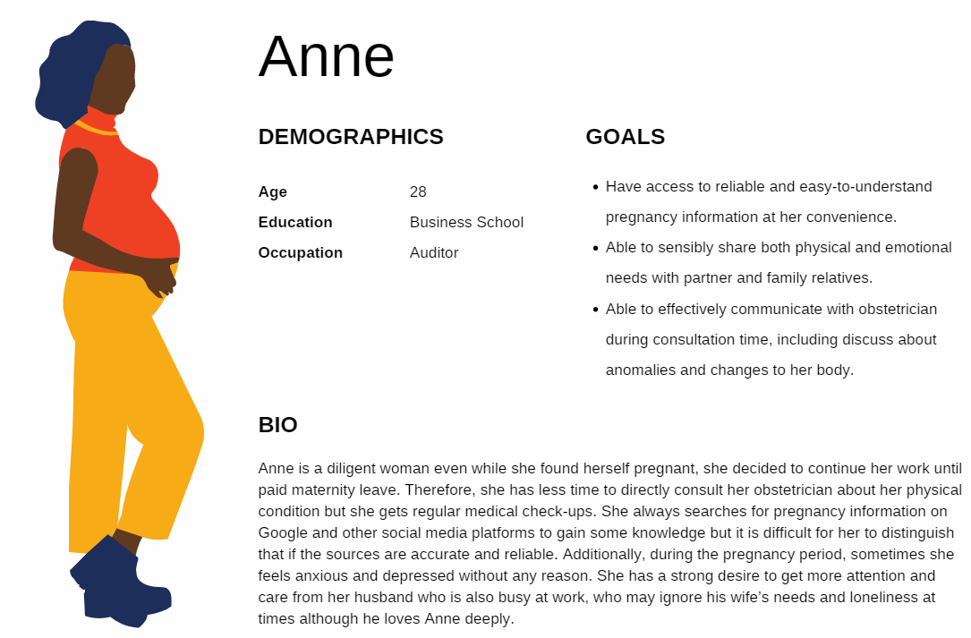

**Figure 1:** Persona - A pregnant woman.

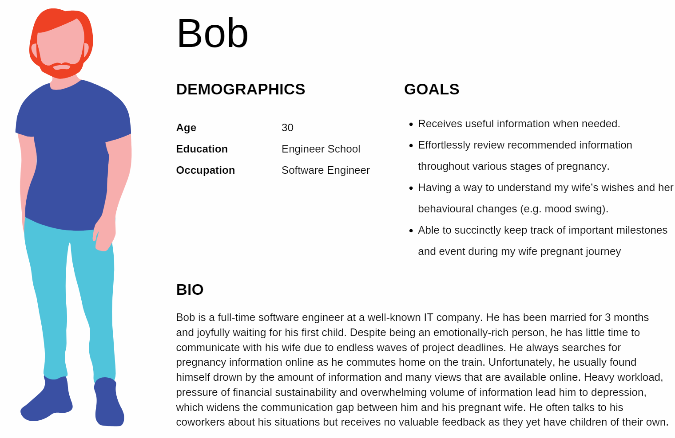

**Figure 2:** Persona - A husband.

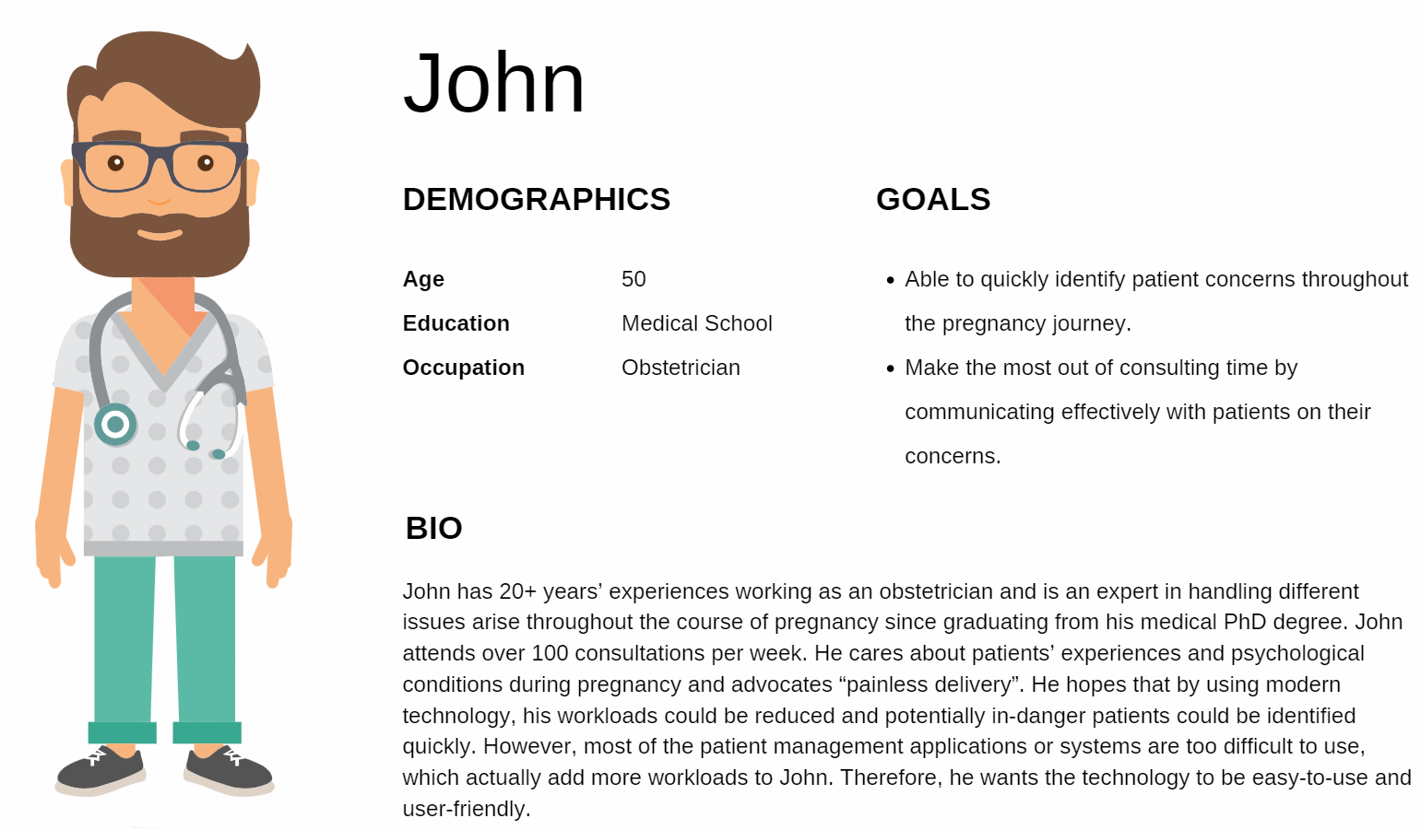

**Figure 3:** Persona - A doctor.

## 2.4. Evaluation of Existing Technological Intervention

### 2.4.1 Motivation

To understand the current approach and effectiveness of technological intervention on antenatal depression, four popular technology solutions appeared in literature and mobile app stores were selected to evaluate in detail. Insights, including advantages and drawbacks of each solution, will be consolidated to form the building blocks for a better future technology.

### 2.4.2 Evaluation

1. A clinical mental risk score assessment application

Kingston et al. (2015) discussed a clinical mental risk scoring via web-based assessment for women with high-risk pregnancy. It is a well-designed and ready to be used routinely in hospital environment, where mental health support is absent (Kingston et al., 2015). The web application outlines critical information for understanding depression in pregnant women as well as associated risks. Future intervention which aim at mental health can use the application as a baseline in creating and organising crucial information. It provides a questionnaire through which pregnant women will give answers and be assessed by health professionals. Even though it aims to provide clinically-proven intervention to mental depression, it also restricts the potential usage to hospital environments. Because the intervention is coupled with the presence of health professional, pregnant women cannot use the application outside of hospitals. And notably, the questionnaire is not a user-centric approach but rather a provider-centric approach because it neither deliver usefulness nor user engagement (Albert & Tullis, 2013).

1. A mental health social support platform for pregnant women

Nabi et al. (2013) pointed out that social media plays a prominent role in providing social support and shared-personal experiences which in turn, may have positive impacts on reducing stress via a perceived-level of satisfaction (**Figure 4**). The solution lays out areas of frequently asked topics and concerns from pregnant women and their family members. Additionally, it offers a degree of information co-creation. Users of the solution join an online community in which they can inquire for information as well as answer others’ concerns. However, the quality of information is debatable and information that each user receives can vastly vary from person to person, from community to community (Chiou et al., 2017).

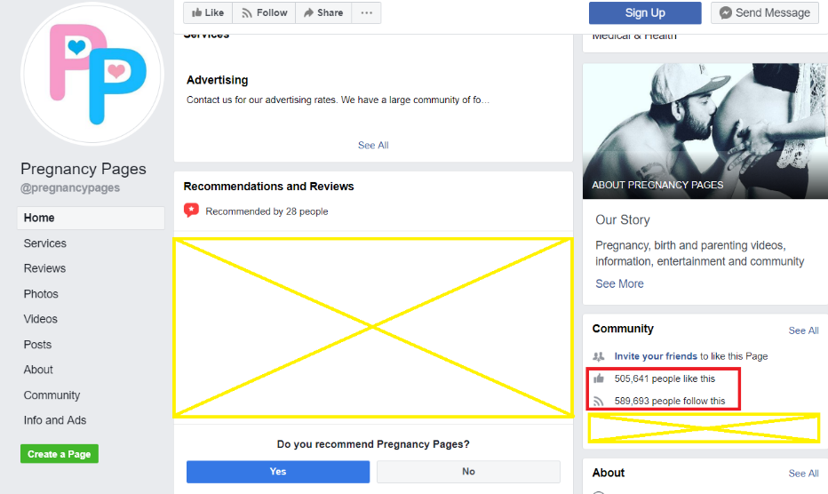

**Figure 4:** Screenshot ofPregnancy Community Support page (Reprinted from “Pregnancy Pages”, 2019).

1. “Pregnancy Tracker and Baby Due Date Calculator” application

The application is among the most popular applications for pregnant women and currently available on Google Play store (**Figure 5**). It provides detailed information about different concerns during each stage of pregnancy, which sets a good example of simplifying information delivery with consideration of end-users. Because it helps users focus on information by stages of pregnancy, the users can query for detailed information and self-calculate due date of their babies. Despite the strength of having good visual designs, quality of information and its level of details are still of concerns to users (**Figure 6**).

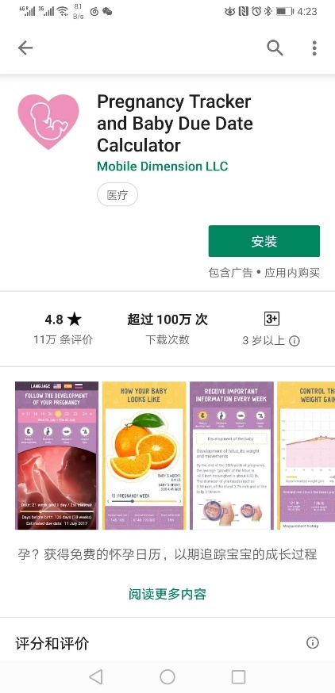

**Figure 5:** Pregnancy Tracker and Baby Due Date Calculator (Reprinted from “Pregnancy Tracker, “ 2019).

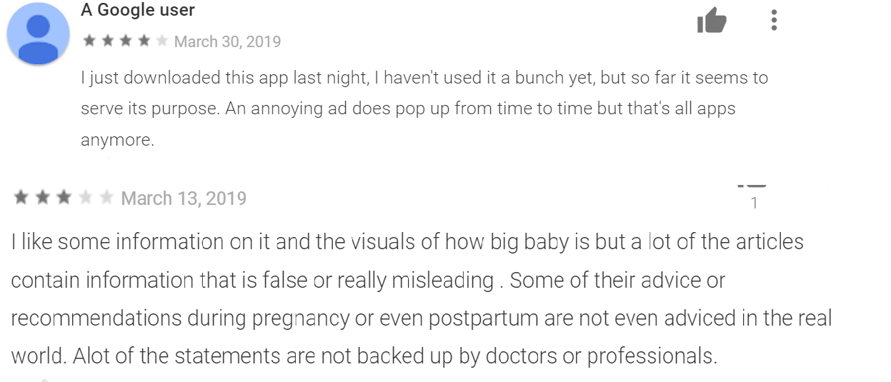

**Figure 6:** User feedback (Reprinted from “Pregnancy Tracker, “ 2019).

1. “Z-baby Plus” application

“Z-Baby” provides information about simulated baby development and required calorie, as well as the locations of nearest hospitals (Sinthanayothin et al., 2014). An upgraded version of the application, known as “Z-baby Plus” (Figure 7), is now available on the Google Play store. The later version allows users to even keep track of baby due date. Both applications are easy and amusing to use as they provide an interactive simulation of foetus development. It proves that pregnancy-related technological intervention can be entertaining while delivering important information. However, it solely focuses on just a few aspects of pregnancy journey.

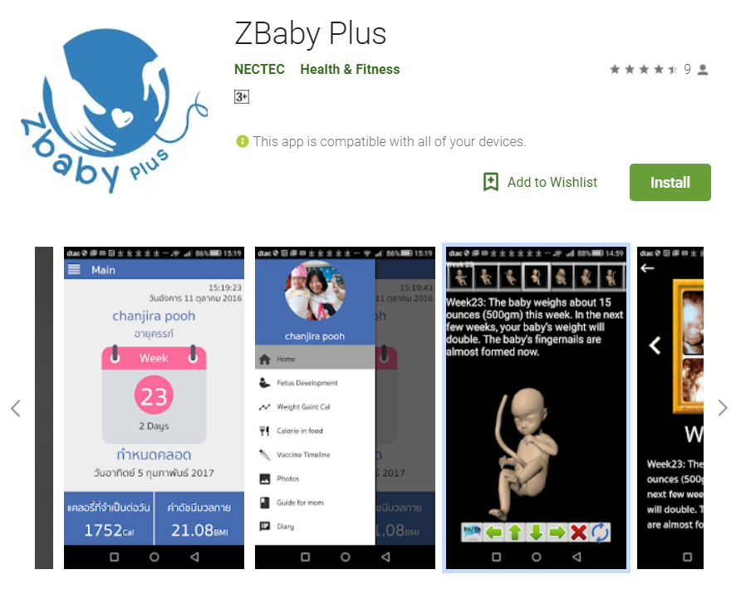

**Figure 7:** ZBaby Plus Application (*Reprinted from* (Reprinted from “ZBaby Plus“ 2019).

# 3. Discussion

## 3.1 Opportunities

Firstly, many solutions are existed but only a few take pregnant women and their family members at the centre of information delivery mechanism. Either the solutions provide too detailed information or too little information. And, users have to combine information from various sources. This also opens pregnant women and their family members to higher level of confusion.

Secondly, the solutions create a behaviour in pregnant women where they tend to seek mental supports from online communities first instead of their family members. Together with social, cultural and personal factors, this behaviour widens the communication gap between pregnant women and their family members.

Thirdly, Kothari and Moolani (2015) claim pregnant women often find search engine as the first choice for medical information. Besides, Da Costa et al. (2018) pointed out that time constraint is one of the main concerns when seeking information or supports. Thus, information that is delivered to pregnant women and their family members must be available within an acceptable timeframe, is credible and must meet requestors’ goals.

Lastly, the solutions do not provide historical tracking of acquired information and pregnant women must self-manage this information separately. Hence, it is reasonable to say that the information which the women gain from these apps may not be mentioned in the periodical consultations with their obstetrician. Based on Larsson’s research, solely 30% of pregnant women would refer to their physician for pregnancy knowledge retrieved from online sources (Larsson, 2009).

## 3.2 Vision

Ideally, the future technological solution should empower family members, especially husbands, by giving a tool which enhances their knowledge of pregnancy while promoting bonding between pregnant women and their loved ones. Additionally, it should lift off the extra-burden of information seeking while providing a user-centric solution to mental health support.

## 3.3 Conceptual Design

1. Characterised virtual assistant

Instead of having users digging into the vast and confusing sources of information, the future solution should deliver information in the same manner with online social support. With that in mind, a potential technological solution can come in the form of a chatbot. It simulates the effect of having a friend to talk and to listen. The friend, who is always there whenever the users need it most, can listen and respond with the most useful, precise yet concise information. Furthermore, the chatbot is characterised via intended communication tones, grammatical and word choices, to create a perceived-level of influence and intimacy on the users (**Figure 8** depicts a potential persona of the chatbot).

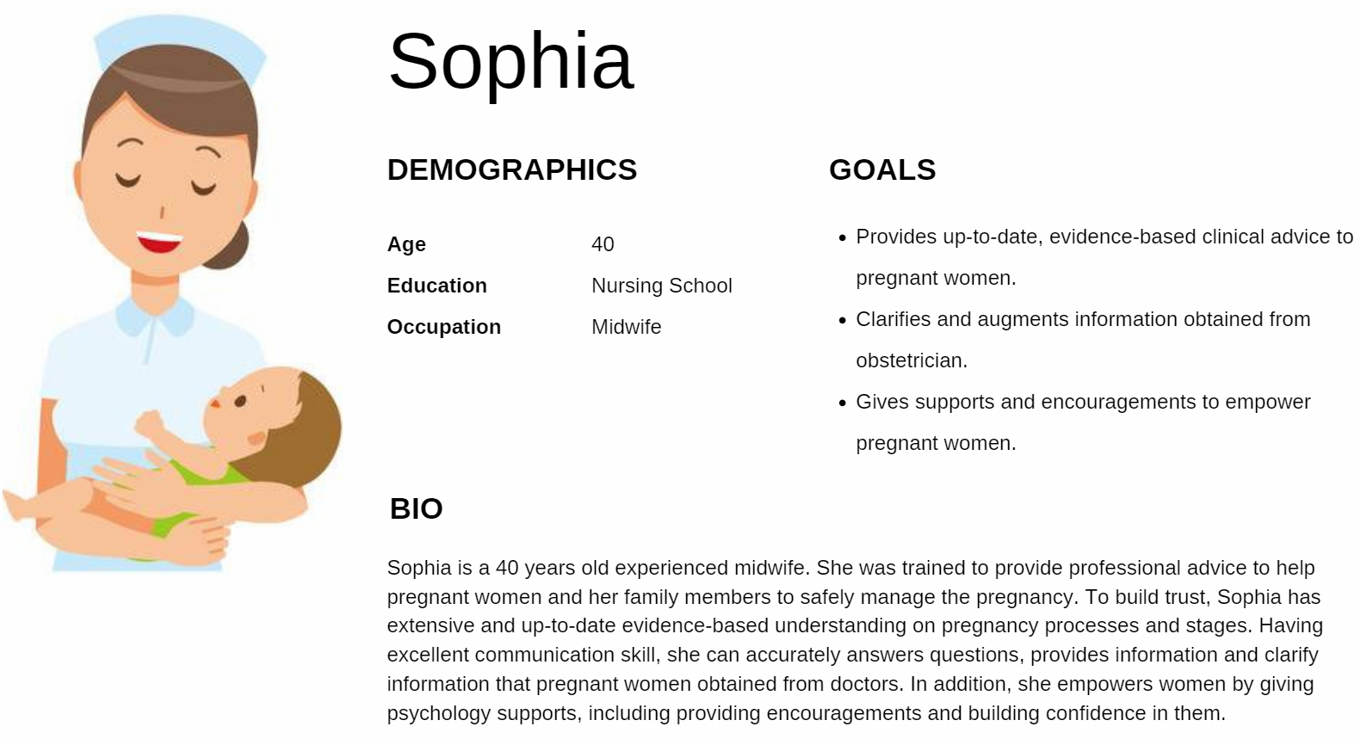

**Figure 8:** Persona - Characterised Chatbot.

1. Interactive supports between pregnant women and carers

Instead of distancing pregnant women from their carers or family members, the future solution should promote the bonds between them. It can roleplay as a Friend-in-the-middle to deliver insightful messages between pregnant women and their carers at minimum efforts required from both sides. For instance, if a pregnant woman repeatedly communicates with the chatbot about loneliness, the chatbot can start a conversation with her husband about her *concerns*, in the friendliest manner such as *“Hey Bob, your wife is feeling lonely. Maybe, you should have a date with her*”. Likewise, the husband can actively create a dating invitation which is delivered to the wife via the chatbot. And, the chatbot should proactively remind carers about important milestones and associated information throughout the pregnancy journey.

1. Pre-processed and hierarchical information throughout the pregnancy journey

Instead of delivering unfriendly and confusing information, the future solution should *deliver* or *prioritise* information that is the most useful to the questions being asked and the most relevant information to the current stage of women in their pregnancy journey. It should start with summarised information and still allows users to explore for related details. And, the trustworthy of provided information should be visible to the users. For instance, a cartoonish “clinically-approved” badge can convey the credibility of information. Lastly, it should plausibly adopt animated or pictographic messages (Delp & Jones, 1996) and provide *continuous* supports (E.g. antenatal) to the users.

1. Smart Questions and Answers

Instead of having pregnant women to keep track of their concerns, the future solution should cleverly organise the concerns into reusable forms. Such intentions can be realised with the “Frequently Asked Questions & Answers” concept. Questions that frequently asked by other pregnant women or communities related to pregnancy. Answers are provided with a mark of validation if the answer is accredited by an authorised party (E.g. health professionals). If the questions and answers are useful, the users should be able to give feedback. Otherwise, they can add the question to a “to-be-answered” question list which can be shown to their obstetrician in future appointments, without a need of carrying a paper question list. This can improve the efficiency of consultation activities.

# 4. Conclusion

Antenatal depression is a common issue encountered by Australian women. Through the evaluation of existing technological interventions, although many pregnant women suffer depression or anxiety, they are unable to receive sufficient and personalised supports from these solutions. Moreover, the provided information is unstructured and confusing which cast additional mental loads to the users. Therefore, a conceptual user-centric design is proposed. The characterised chatbot is a prominent candidate in delivering information as well as an intermediary in bridging communication gap between pregnant women and their family members. Notably, the user experience and qualitative factors of information are at the baseline of the conceptual design. Undoubtedly, through the implementation of the design, pregnant women will receive all-sided care from both virtual and real world.

**Word count: 2202**

# 5. References

Adewuya, A. O., Ola, B. A., Aloba, O. O., Dada, A. O., & Fasoto, O. O. (2007). Prevalence and correlates of depression in late pregnancy among Nigerian women. Depression and anxiety, 24(1), 15-21.

Albert, W., & Tullis, T. (2013). Measuring the user experience: collecting, analyzing, and presenting usability metrics. Elsevier Science & Technology Books.

Atkinson, L., & Teychenne, M. (2019). Psychological, Social and Behaviour Changes During Pregnancy: Implications for Physical Activity and Exercise. In Exercise and Sporting Activity During Pregnancy (pp. 19-43). Springer, Cham.

Bayrampour, H., McDonald, S., & Tough, S. (2015). Risk factors of transient and persistent anxiety during pregnancy. Midwifery, 31(6), 582-589.

Biaggi, A., Conroy, S., Pawlby, S., & Pariante, C. M. (2016). Identifying the women at risk of antenatal anxiety and depression: a systematic review. Journal of affective disorders, 191, 62-77.

Chiou, W. K., Kao, C. Y., Lo, L. M., Huang, D. H., Wang, M. H., & Chen, B. H. (2017, July). Feasibility of utilizing E-mental health with mobile app interface for social support enhencement: A conceptional solution for postpartum depression in Taiwan. In International Conference of Design, User Experience, and Usability (pp. 198-207). Springer, Cham.

Da Costa, D., Zelkowitz, P., Nguyen, T. V., & Deville-Stoetzel, J. B. (2018). Mental health help-seeking patterns and perceived barriers for care among nulliparous pregnant women. Archives of women's mental health, 21(6), 757-764.

Delp, C., & Jones, J. (1996). Communicating information to patients: the use of cartoon illustrations to improve comprehension of instructions. Academic Emergency Medicine, 3(3), 264-270.

Guerra-Reyes, L., Christie, V. M., Prabhakar, A., Harris, A. L., & Siek, K. A. (2016). Postpartum health information seeking using mobile phones: experiences of low-income mothers. Maternal and child health journal, 20(1), 13-21.

Kingston, D., Janes-Kelley, S., Tyrrell, J., Clark, L., Hamza, D., Holmes, P., ... & Austin, M. P. (2015). An integrated web-based mental health intervention of assessment-referral-care to reduce stress, anxiety, and depression in hospitalized pregnant women with medically high-risk pregnancies: a feasibility study protocol of hospital-based implementation. JMIR research protocols, 4(1), e9.

Kothari, M., & Moolani, S. (2015). Reliability of “Google” for obtaining medical information. Indian journal of ophthalmology, 63(3), 267.

Nabi, R. L., Prestin, A., & So, J. (2013). Facebook friends with (health) benefits? Exploring social network site use and perceptions of social support, stress, and well-being. Cyberpsychology, Behavior, and Social Networking, 16(10), 721-727.

Ogbo, F. A., Eastwood, J., Hendry, A., Jalaludin, B., Agho, K. E., Barnett, B., & Page, A. (2018). Determinants of antenatal depression and postnatal depression in Australia. BMC psychiatry, 18(1), 49.

Pregnancy Pages (2019, April). Retrieved from <https://www.facebook.com/pregnancypages/>

Pregnancy Tracker and Baby Due Date Calculator (2019, April). Retrieved from <https://play.google.com/store/apps/details?id=ru.mobiledimension.kbr&hl=en>

Ramezani, S., Khosravi, A., Motaghi, Z., Hamidzadeh, A., & Mousavi, S. A. (2017). The effect of cognitive-behavioural and solution-focused counselling on prevention of postpartum depression in nulliparous pregnant women. Journal of reproductive and infant psychology, 35(2), 172-182.

Sinthanayothin, C., Bholsithi, W., Wongwaen, N., & Xuto, P. (2014, July). ZBaby: Android application for pregnancy due date, fetus development simulation and weight gain during pregnancy. In 2014 International Computer Science and Engineering Conference (ICSEC) (pp. 62-66). IEEE.

ZBaby Plus (2019, April). Retrieved from <https://play.google.com/store/apps/details?id=nectec.zbaby>